 | Autumn 2022 | Spring 2023 | Summer 2023
English Reading | Out and About  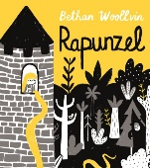  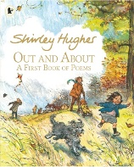  Rapunzel | Leaf  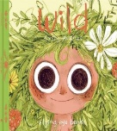  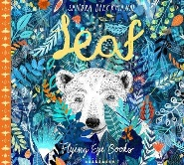  Wild | One Day on our Blue Planet  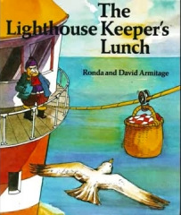  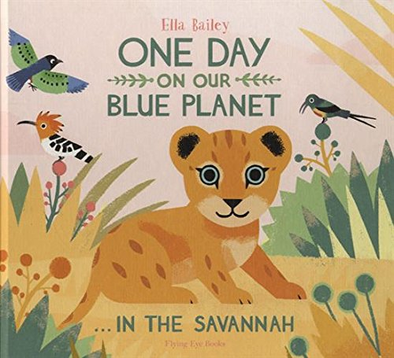  The Lighthouse Keeper’s Lunch
English Writing | Holiday Reccount  Fre-Verse Poetry  Narrative and descriptive Writing  Instructions | Non- chronological Report  Letter  Adventure Narrative  Explanation | Animal Fact File  Persuasive Poster  Narrative  Letter
Maths | Place Value  Addition & Subtraction  Shape | Place Value  Addition & Subtraction  Length & Height  Weight & Volume | Multiplication & Division  Fractions  Position & Direction  Place Value  Money  Time
Science | Seasonal Changes  Everyday Materials | Introduction to Plants  Plant Growth and Care | Animals including humans-  - About Animals  - Growth
Geography | Locational knowledge/ Human and physical geography- Weather and Seasons | Locational knowledge/ Human and physical geography- Hot and Cold Places | Place Knowledge/ Human and physical geography- Mugurameno Village, Zambia (comparison study)
History | Events beyond living memory – Castles, inc. Tamworth Castle  Trip to Tamworth Castle | Lives of significant individuals- The Wright Brothers & Amy Johnson | Lives of significant individuals- Mary Anning & David Attenborough
RE
Art and Design | Paul Klee- Cubism castles (drawing; using oil pastels/chalks) | Edward Saidi- Tinga-Tinga art (painting); African patterns | John Piper- street scene & lighthouses (mixed media/collage)
DT | Year 1/2 Structures- Freestanding Structures | Year 1/2 Textiles- Templates and joining instructions. | Year 1/2 Food- Preparing fruit and vegetables e.g. fruit salad/kebabs/smoothies
Computing | Online Safety & Exploring Purple Mash  Maze Explorers  Questioning | Online Safety  Animated Story Books  Making Music | Spreadsheets  Pictograms  Presenting Ideas
PE | Hockey  Tag Rugby  Gymnastics  Dodgeball | Dance  Badminton  Orienteering  Fitness | Basketball  Maypole  Athletics  Cricket
PSHE | Me and my Relationships  Valuing Difference | Keeping myself safe  Rights and Responsibilities | Being my best  Growing and changing
Music | Voice | Pitch | 20th Century Music

