Snarestone Church of England

(Aided) Primary School

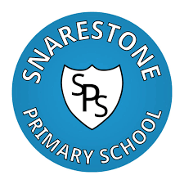

Relationships and Sex Education Policy

Date of Review: May 2021
Date of Next Review: May 2023

Signed Headteacher:

Signed Chair of Governors:

Contents
- Policy aims
- Policy development
- Statutory requirements
- Ethos and values
- Definitions and curriculum content
    - Relationships Education
    - Health Education
    - Sex Education
- Delivery
    - Timetabling
    - Staffing
    - Resources
    - External visitors
    - Signposting support
- Inclusive and accessible RSE
- Safeguarding and confidentiality
- Answering pupil questions
- Staff training
- Monitoring and assessment
- Working with parents and carers

Appendix
- RSE curriculum map
- Statutory content
- Parental withdrawal monitoring form

1. Policy aims
The school publishes this policy as a statutory requirement and with the following aims:
- To offer a clear guide to parents, carers, staff and visitors; defining RSE as a subject and explaining its delivery at school
- To set out the curriculum requirements and explain what will be taught when
- To give information to parents and carers about their involvement with RSE

2. Policy development
As set out in government guidance, the policy has been developed through a process of consultation involving school staff, parents/carers, pupils and governors.
Development of the policy has been supported by school governors, who have ratified the finished document.

3. Statutory requirements
The Children and Social Work Act 2017 makes Relationships Education and Health Education statutory in all Primary schools and the guidance is mandatory. Expectations on primary schools are as follows:
- Relationships Education will be compulsory in all primary schools (or those pupils receiving primary education) – this includes academies, free schools and independent schools
- Health Education will be compulsory in all primary and secondary schools (or those pupils receiving primary or secondary education) – this includes all academies and free schools but not independent schools as PSHE is already statutory in these schools.
RSE supports us in our statutory duties of Keeping Children Safe in Education

4. Ethos and values
Through RSE we deliver key learning that supports the school’s agreed ethos and values.
Our RSE delivery is fully in line with our vision as we aim to ensure that all our pupils leave us fully prepared for the next stage of their life:
As a community, we are working together to ensure educational excellence underpinned by our Christian ethos and values, enabling all to live a rich and abundant life and to achieve their full potential. Each individual should leave us fully prepared for the next stage of their life.
(Reflecting John 10:10)
Key school values supported by RSE include:
- Respect for self and others
- Building positive caring relationships
- Respecting diversity
- Feeling safe and valued
- Self-awareness and self esteem
- Exploration of rights, duties and responsibilities
We believe that all pupils should receive accurate information that supports their needs and explains their rights. RSE gives young people the opportunity to explore and develop their own attitudes and values and to respect the views of others.

5. Definitions and curriculum content
Relationship and Sex Education (RSE) supports and guides children and young people in life-long learning about relationships, emotions, the human biology of sex, sexuality and sexual health. In partnership with parents and carers, we help our young people to understand and manage their physical and emotional development during adolescence and to prepare for the decisions to be made in adult life.
The school’s RSE curriculum (appendix 1) has been designed in consultation with parents, pupils and staff, taking into account the age, needs and feelings of pupils.

- Relationships Education
The focus of Relationships Education is on teaching the fundamental building blocks and characteristics of positive relationships, with particular reference to friendships, family relationships, and relationships with other children and with adults. Dfe guidance requires us to teach objectives under the following topics;

- Families and people who care for me
- Caring Friendships
- Respectful Relationships
- Online Relationships
- Being Safe
- Health Education
The focus of Health Education is on teaching the characteristics of good physical health and mental wellbeing. Elements of our Health Education are timetabled to complement and support the teaching of RSE. Dfe guidance requires us to teach objectives under the following topics;

- Mental Wellbeing
- Internet Safety and Harms
- Physical Health and Fitness
- Healthy Eating
- Drug, Alcohol and Tobacco
- Health and Prevention
- Basic First Aid
- The Changing Adolescent Body (Puberty)
- Sex Education
The Dfe advise that all primary schools have a programme of Sex Education tailored to the age and the physical and emotional maturity of the pupils. Our programme contains the statutory elements of the Science curriculum (see appendix 2)
Sex education outside of science
Our programme also contains non-statutory content which the school feels is age-appropriate and does an important job of helping to answer some of the questions that pupils are asking as they come to the transition period between primary and secondary school.
The scheme of work that we use forms a spiralling curriculum of Relationships and Sex Education. We feel that on the whole the Sex Education element of the resource is in line with the science curriculum, whilst lessons on puberty form part of statutory Health Education. The exception would be sessions in year 6 which include age-appropriate discussions on adult sexuality and how a baby is conceived and born.

Parents will be informed of when these lessons are taking place. If they wish to withdraw, procedures will be followed as set out in section 12.

6. Delivery
- Timetabling: RSE will be taught for approximately 1 hour per week during the second half of the summer term.
- Staffing: RSE will be taught by class teachers.
- Resources: RSE is delivered using quality assured up to date resources from CWP resources and Coram Life Education
- External visitors: Visitors may be used from time to time to enhance, not replace, our delivery of RSE. Visitors will be checked to ensure that what they are offering is of quality and appropriate for our students.
- Signposting support: All RSE sessions will include signposting information for students, including identifying safe and appropriate adults for them to go to for help and support. This will include members of the school pastoral care team but with also include the signposting of external agencies such as Childline.

7. Inclusive and accessible RSE

The school has a duty, under the Equalities Act (2010), to ensure that it does not discriminate against people with protected characteristics. A whole-school approach is taken to inclusivity and accessibility and care is taken to ensure that teaching meets the needs of all students. The school will:

- respect that the school community includes people of different faiths, beliefs and cultural backgrounds
- acknowledge that pupils will grow up in many kinds of families including single parent families, LGBT parents, families headed by grandparents, adoptive parents, foster parents/carers amongst other structures
- recognise that some staff or pupils may identify as LGBT
- take care that resources, books and displays represent all kinds of families
- take positive action to tackle bullying and discrimination

Particular care will be taken to ensure that RSE is accessible to pupils with special educational needs and disabilities. The SEND code of practice outlines the need for schools to prepare children for adulthood. These pupils can be more vulnerable to exploitation and bullying which means that sensitive and age-appropriate Relationships and Health Education is an essential part of their learning. We will ensure that our curriculum is accessible to all pupils by using differentiated resources, small group work or supporting pupils in-class.

8. Safeguarding and confidentiality
Good practice allows children an open forum to discuss potentially sensitive issues. Such discussions can lead to increased safeguarding reports. Children should be made aware of how to raise their concerns or make a report and how any report will be handled. This should include processes when they have a concern about a friend or peer.

All sessions will begin with a group agreement designed to create a safe space for discussion. Sessions will include information, signposting appropriate help and support, including parents and carers, and the school’s pastoral team.
All school staff have completed safeguarding training and should be mindful of the school’s safeguarding policy and procedures when delivering RSE sessions. Staff understand that they cannot offer unconditional confidentiality to pupils and pupils will be made aware of this. Staff will work within the school's agreed procedures for recording and reporting disclosures and the nature of access to this information.

9. Answering pupil questions
As with all subjects, pupils will have questions relating to what they have been learning and teachers will use their judgement to answer questions in an age appropriate way. If a teacher is unsure about whether a particular question is appropriate to be answered in a whole-class setting they may ask for support from the subject lead or senior leadership team.

10. Staff training
RSE should be delivered by staff who have received up-to-date training and who feel confident with the subject. Training includes information on how to use ground rules, facilitate group discussions, answer difficult questions and the delivery of sensitive content. Training may be provided in-school, on-line or as part of local support offered by Leicestershire and Rutland Healthy Schools.

11. Monitoring and assessment
The school has the same high expectations of pupils’ work in RSE as in other areas of the curriculum. The subject lead will support teachers to assess pupil work and progress. Monitoring includes lesson observations, learning walks, pupil interviews and work scrutiny.
Pupil feedback will be important to the future development of RSE at the school. Regular subject audits will ensure that provision is up to date and meeting the needs of pupils.

12. Working with parents and carers
The school has consulted parents and carers and their views have been taken into consideration when planning and delivering RSE. Parents and carers will be kept informed about what is delivered and when, so that they can support this learning at home.
Parents and carers will be invited to a meeting where they will be able to view resources, including any used for Sex Education taught outside of science.
Parents and carers have the right to withdraw their child from Sex Education outside of science (as outlined above). From September 2020 parents do not have the right to withdraw their child from lessons on Relationships or Health Education or the Science Curriculum.
If a parent or carer wishes to withdraw their child from Sex Education, we ask that they discuss it with the Headteacher and then a request for withdrawal should be put in writing using the form found in Appendix 3 of this policy and addressed to the Headteacher.
Parents, carers and staff should be aware that pupils who are withdrawn from Sex Education will have questions about why this has happened. It should also be understood that pupils may ask their peers questions about lesson content.
Alternative work will be given to pupils who are withdrawn from Sex Education.

Appendix 1
RSE curriculum map
This resource forms a spiralling curriculum of Relationships and Sex Education. We feel that on the whole the Sex Education element of the resource is in line with the science curriculum. Lessons on puberty form part of statutory Health Education. The exception would be sessions in year 6 which include age-appropriate discussions on adult sexuality and how a baby is conceived and born - parents will be given the right to excuse their children from these lessons.
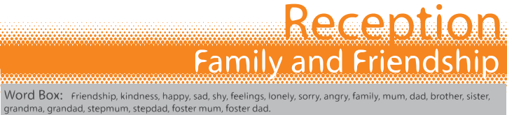
Statutory Guidance | Title | Learning Intentions and Learning Outcomes
Relationships Education  Caring friendships (2a,2c)  Health Education  Mental wellbeing (6b,6c,6g) | Lesson 1: Caring | Learning Intention  To recognise the importance of friendship  Learning Outcomes  Know that friendships can make us feel happy  Know some ways that we can make new friends feel welcome
Relationships Education  Caring friendships (2d)  Health Education  Mental wellbeing (6b,6c) | Lesson 2: Being Kind | Learning Intention  To recognise the importance of saying sorry and forgiveness  Learning Outcomes  Know that arguing with friends and then making up can make friendships stronger  That resorting to violence is never right
Relationships Education  Families and people who care for me (1a)  Caring friendships (2a)  Respectful relationships (3a) | Lesson 3: Families | Learning Intention  To recognise that all families are different  Learning Outcomes  Identify different members of the family  Understand how members of a family can help each other
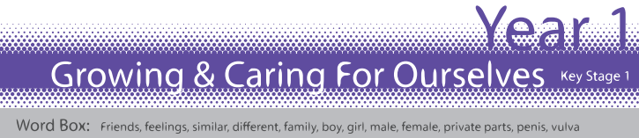
Statutory Guidance | Title | Learning Intentions and Learning Outcomes
Relationships Education Respectful relationships (3a,3e)  Health Education  Mental wellbeing (6b,6c) | Lesson 1: Different Friends | Learning Intention  To understand that we are all different but can still be friends  Learning Outcomes  Know that we can be friends with people who are different to us
Key Stage 1 Science - Identify, name, draw and label the basic parts of the human body | Lesson 2: Growing and Changing | Learning Intention  To discuss how children grow and change  Learning Outcomes  Understand that babies need care and support  Know that older children can do more by themselves
Relationships Education Families and people who care for me (1a,1b,1c,1d,1f)  Caring friendships (2e)  Respectful relationships (3a,3e)  Being Safe (5d,5e)  Health Education  Mental wellbeing (6b,6c) | Lesson 3: Families and Care | Learning Intention  To explore different types of families and who to ask for help  To identify who can help when families make us feel unhappy or unsafe  Learning Outcomes  Know there are different types of families  Know which people we can ask for help
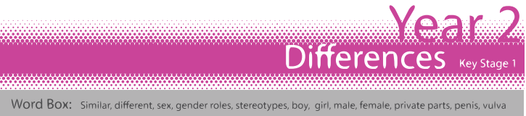
Statutory Guidance | Title | Learning Intentions and Learning Outcomes
Relationships Education  Respectful relationships (3a,3g)  Key Stage 1 Science - Identify, name, draw and label the basic parts of the human body | Lesson 1: Differences | Learning Intention  To introduce the concept of gender stereotypes  To identify differences between males and females  Learning Outcomes  Understand that some people have fixed ideas about what boys and girls can do  Describe the difference between male and female babies
Relationships Education Respectful relationships (3a)  Key Stage 1 Science - Notice that animals, including humans, have offspring that grow into adults | Lesson 2: Male and Female Animals | Learning Intention  To explore some of the differences between males and females and to understand how this is part of the lifecycle  Learning Outcomes  Describe some differences between male and female animals  Understand that making a new life needs a male and a female
Key Stage 1 Science - Identify, name, draw and label the basic parts of the human body | Lesson 3: Naming Body Parts | Learning Intention  To focus on sexual difference and name body parts  Learning Outcomes  Describe the physical differences between males and females  Name the different body parts
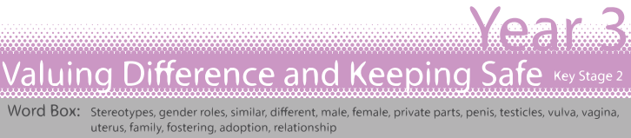
Statutory Guidance | Title | Learning Intentions and Learning Outcomes
Relationships Education  Respectful relationships (3a) | Lesson 1: Body Differences | Learning Intention  To identify that people are unique and to respect those differences  To explore the differences between male and female bodies  Learning Outcomes  Know and respect the body differences between ourselves and others  Name male and female body parts using agreed words
Relationships Education  Caring friendships (2e)  Respectful relationships (3b,3d,3f)  Being safe (5a,5b,5c,5d,5f,5g) | Lesson 2: Personal Space | Learning Intention  To consider appropriate and inappropriate physical contact and consent  Learning Outcomes  Understand that each person’s body belongs to them  Understand personal space and unwanted touch
Relationships Education  Families and people who care for me (1a,1b,1c,1d,1f,)  Being safe (5d,5f,5g, 5h) | Lesson 3: Help and Support | Learning Intention  To explore different types of families and who to go to for help and support  Learning Outcomes  Understand that all families are different and have different family members  Identify who to go to for help and support
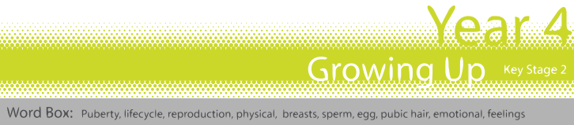
Statutory Guidance | Title | Learning Intentions and Learning Outcomes
Health Education  Changing adolescent body (8a)  Key Stage 2 Science - describe the life process of reproduction in some plants and animals | Lesson 1: Changes | Learning Intention  To explore the human lifecycle  To identify some basic facts about puberty  Learning Outcomes  Understand that puberty is an important stage in the human lifecycle Know some changes that happen during puberty
Health Education  Mental wellbeing (6a,6b,6c,6d,6f)  Changing adolescent body (8a, 8b)  Menstruation (9a)  Key Stage 2 Science - describe the life process of reproduction in some plants and animals - describe the changes as humans develop to old age | Lesson 2: What is Puberty? | Learning Intention  To explore how puberty is linked to reproduction  Learning Outcomes  Know about the physical and emotional changes that happen in puberty  Understand that children change into adults to be able to reproduce if they choose to
Relationships Education  Caring friendships (2b,2c,2d,2e)  Respectful relationships (3a,3b,3d,3e,3f,3h)  Online relationships (4b,4d) | Lesson 3: Healthy Relationships | Learning Intention  To explore respect in a range of relationships  To discuss the characteristics of healthy relationships  Learning Outcomes  Know that respect is important in all relationships including online Explain how friendships can make people feel unhappy or uncomfortable.
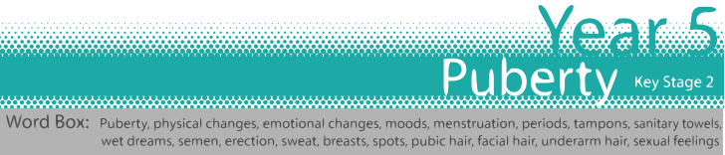
Statutory Guidance | Title | Learning Intentions and Learning Outcomes
Health Education  Mental wellbeing (6c, 6d,6f,)  Changing adolescent body (8a,8b)  Menstruation (9a) | Lesson 1: Talking About Puberty | Learning Intention  To explore the emotional and physical changes occurring in puberty  Learning Outcomes  Explain the main physical and emotional changes that happen during puberty  Ask questions about puberty with confidence
Health Education  Changing adolescent body (8a,8b)  Menstruation (9a) | Lesson 2: The Reproduction System | Learning Intention  To understand male and female puberty changes in more detail  Learning Outcomes  Understand how puberty affects the reproductive organs  Describe what happens during menstruation and sperm production
Health Education  Mental wellbeing (6a,6b,6c, 6d,6e,6f,)  Changing adolescent body (8a,8b)  Menstruation (9a) | Lesson 3: Puberty Help and Support | Learning Intention  To explore the impact of puberty on the body and the importance of physical hygiene  To explore ways to get support during puberty  Learning Outcomes  Explain how to keep clean during puberty  Explain how emotions/relationships change during puberty  Know how to get help and support during puberty
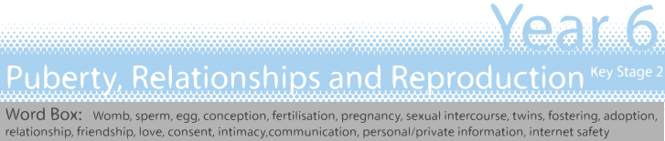
Statutory Guidance | Title | Learning Intentions and Learning Outcomes
Health Education  Mental wellbeing (6c,6d,6f,6g,6i,6j)  Changing Adolescent body (8a,8b) | Lesson 1: Puberty and Reproduction | Learning Intention  To consider puberty and reproduction  Learning Outcomes  Describe how and why the body changes during puberty in preparation for reproduction  Talk about puberty and reproduction with confidence
Relationships Education  Families and people who care for us (1a,1b,1d,1f)  Caring friendships (2a,2b,2c)  Respectful relationships 3b,3d,3h)  Being safe (5a,5b,5c,5d,5e) | Lesson 2: Communication in Relationships | Learning Intention  Exploring the importance of communication and respect in relationships  Learning Outcomes  Explain differences between healthy and unhealthy relationships  Know that communication and permission seeking are important
Relationships Education  Families and people who care for us (1c,1d,1e)  Key Stage 2 Science - recognise that living things produce offspring of the same kind, but normally offspring vary and are not identical to parents | Lesson 3: Families, Conception and Pregnancy | Learning Intention  To consider different ways people might start a family  Learning Outcomes  Describe the decisions that have to be made before having children  Know some basic facts about conception and pregnancy
Relationships Education  Online relationships (4a,4b,4c,4d,4e)  Being safe (5a,5b,5d,5e,5g,5h)  Mental wellbeing (6h,6i) | Lesson 4: Online Relationships | Learning Intention  To explore positive and negative ways of communicating in a relationship  Learning Outcomes  To have considered when it is appropriate to share personal/private information in a relationship  To know how and where to get support if an online relationship goes wrong

Appendix 2
Statutory content
Science Curriculum
Key Stage 1 (age 5-7 years) - Statutory Science Curriculum
- Identify, name, draw and label the basic parts of the human body and say which part of the body is associated with each sense
- Notice that animals, including humans, have offspring which grow into adults
- Describe the importance for humans of exercise, eating the right amounts of different types of food, and hygiene
Key Stage 2 (age 7-11 years) - Statutory Science Curriculum
- Describe the life process of reproduction in some plants and animals
- Describe the changes as humans develop to old age
- Recognise that living things produce offspring of the same kind, but normally offspring vary and are not identical to their parents

Statutory Relationships and Health Education
Full details of what must be covered by the end of primary school can be found in the department for Education guidance https://www.gov.uk/government/publications/relationships-education-relationships-and-sex-education-rse-and-health-education

Appendix 3
Parental withdrawal monitoring form
To be completed by parents
Name of child |  | Class
Name of parent |  | Date
Reason for withdrawing from sex education within relationships and sex education
Any other information you would like the school to consider
Parent signature

To be completed by the school
Agreed actions from discussion with parents
Staff signature

